# Scrum

Scrum is a framework used by Agile methodology.

Scrum is a framework which has solutions for complex problems.

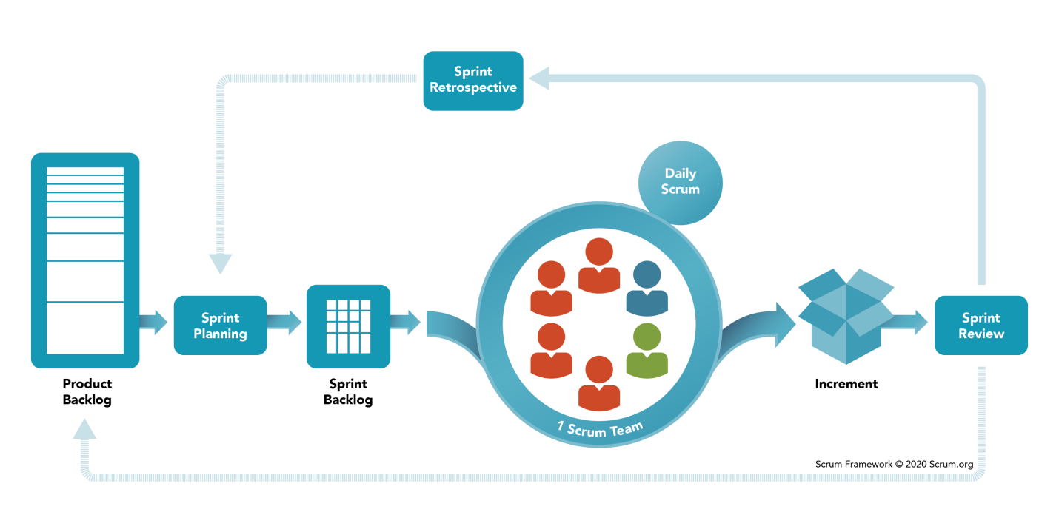

Scrum follows some steps for the product to deliver without any problems.

# Product Backlog:-

For all the project to get complete it takes long time. So, all the requirements got divided into small chunks and it is called as product backlog. In other terms, the set of divided requirements is called as product backlog.

# What is Sprint planning ?

Sprint is nothing but time for the divided requirements. It is usually short span like 2 weeks to 4 weeks

# Sprint backlog:-

For the current sprint the requirements design & priorities are formed as sprint backlog.

# Scrum team:-

Scrum team is nothing but a group of around 6-7 people who are working on the sprint backlog. Team consists Developers, testers etc.,

# Daily Scrum:-

Daily stand up meetings in the morning for around 15 min to 30 min to discuss the day. Normally discuss what to do that day.

# Increment:-

If particular sprint backlog is completed on time & deliver to the client. If it is ready to shippable it is called as Increment.

# Sprint review:-

# Sprint retrospective:-

What went well?

What could be improved ?

In which areas we are lagged & all should be discussed in retrospective.

# Who are all involved in Scrum?

* Product owner
* Scrum master
* Development team

# What are the responsibilities of Scrum master?

* Manage team members issues.
* Remove the obstacles or challenges if any for the team members.
* Fulfill all the needs of team members.
* Assist the team members as well as product owner.
* Encourage the team members, plan the sprint & make the team members work effectively.